בס"ד
Final Project
Leah Pines
https://github.com/LeahPines/ugg-online-store-react.git

Part 1: Deploy App to Cloud Run

Step 1: Docker Image

● Commands Used: * docker build -t leahpines/my-updated-app:latest .
* docker push leahpines/my-updated-app:latest
● Screenshot:
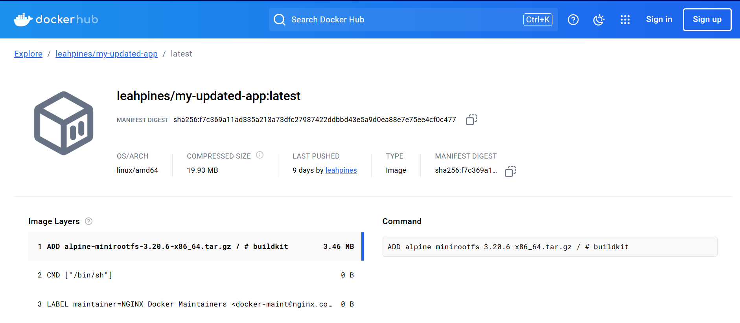

Step 2: Deploy to Cloud Run
● Service Name and Region: html-project, me-west1
● Screenshot:
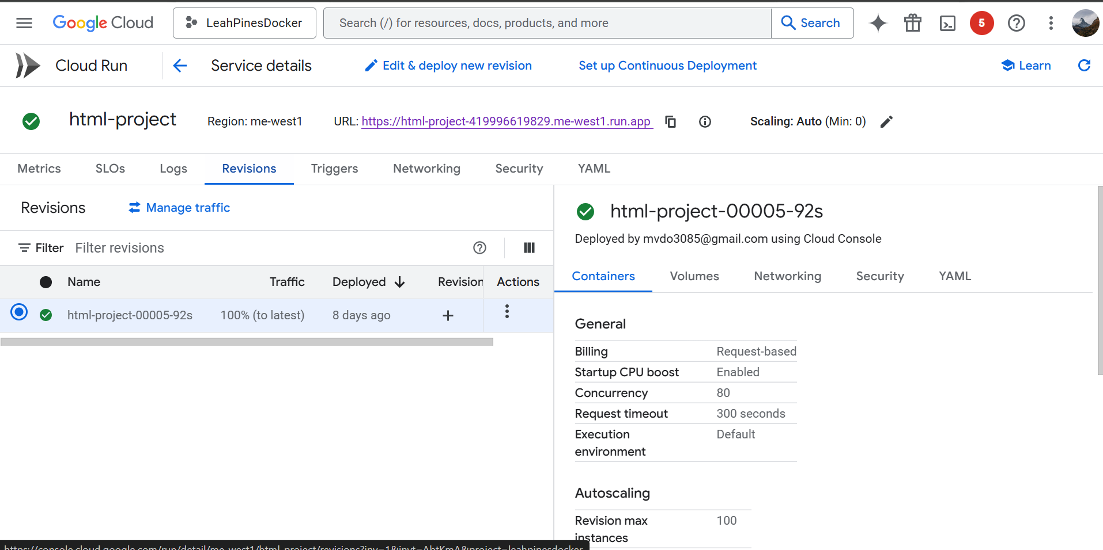

● Public URL: https://html-project-419996619829.me-west1.run.app

● Screenshot:
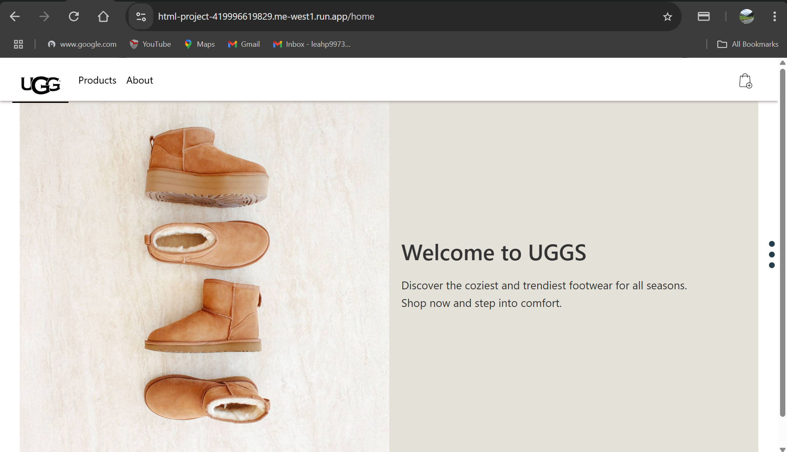

Part 2: Enhance App

Option 1: Cloud Storage Integration

1. Bucket Name: docker-app-bucket
2. Screenshot:
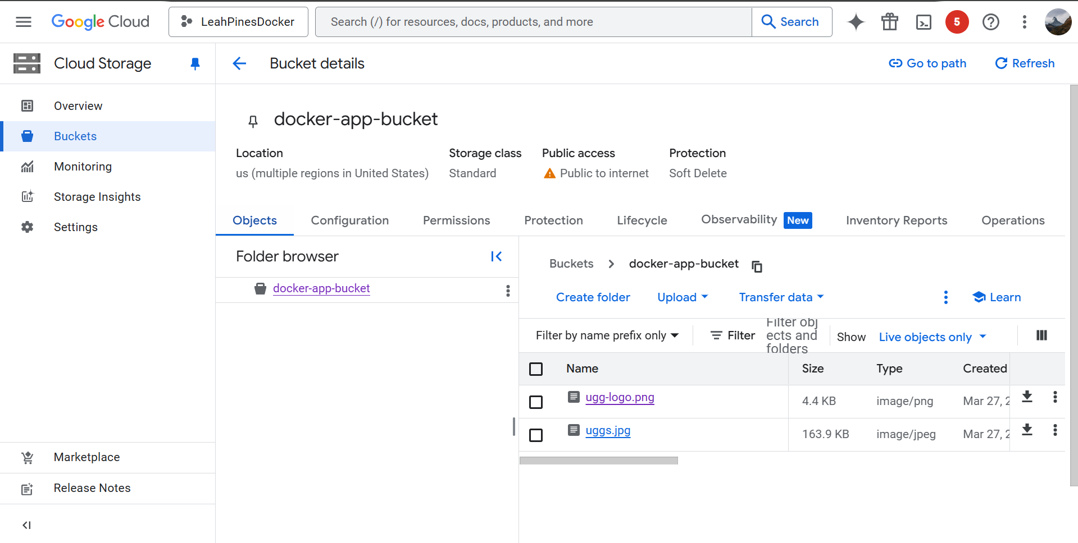

3. Screenshot:

